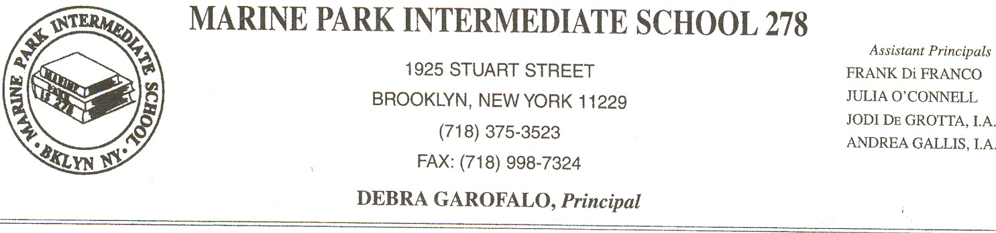

Dear Parent/Guardian of an English Language Learner:

Your child qualifies for supplementary services to increase English language proficiency and academic achievement under Title III of the No Child Left Behind Act.
According to this federal law, any child who is not progressing sufficiently toward a state designated level of English proficiency is entitled to receive extra support. English proficiency is determined by a child’s performance on either the Language Assessment Battery-Revised or the New York State English as a Second Language Achievement Test. According to your child’s test results, he or she can receive additional support to help improve academic performance. To assist your child, these supplementary services will include:
Reading/ELA with ELL methodology
Mathematics with ELL methodology
Science with ELL methodology
Social Studies with ELL methodology

I strongly encourage you to take advantage of these supplementary services. However, if you wish, you may choose to withdraw your child from them, please contact Ms. Sylvester at (718) 375-3523. She will be happy to meet with you to discuss the benefits of these services for your child.

If you have any further questions, please do not hesitate to contact me.

Sincerely yours,
Principal

Debra Garofalo

